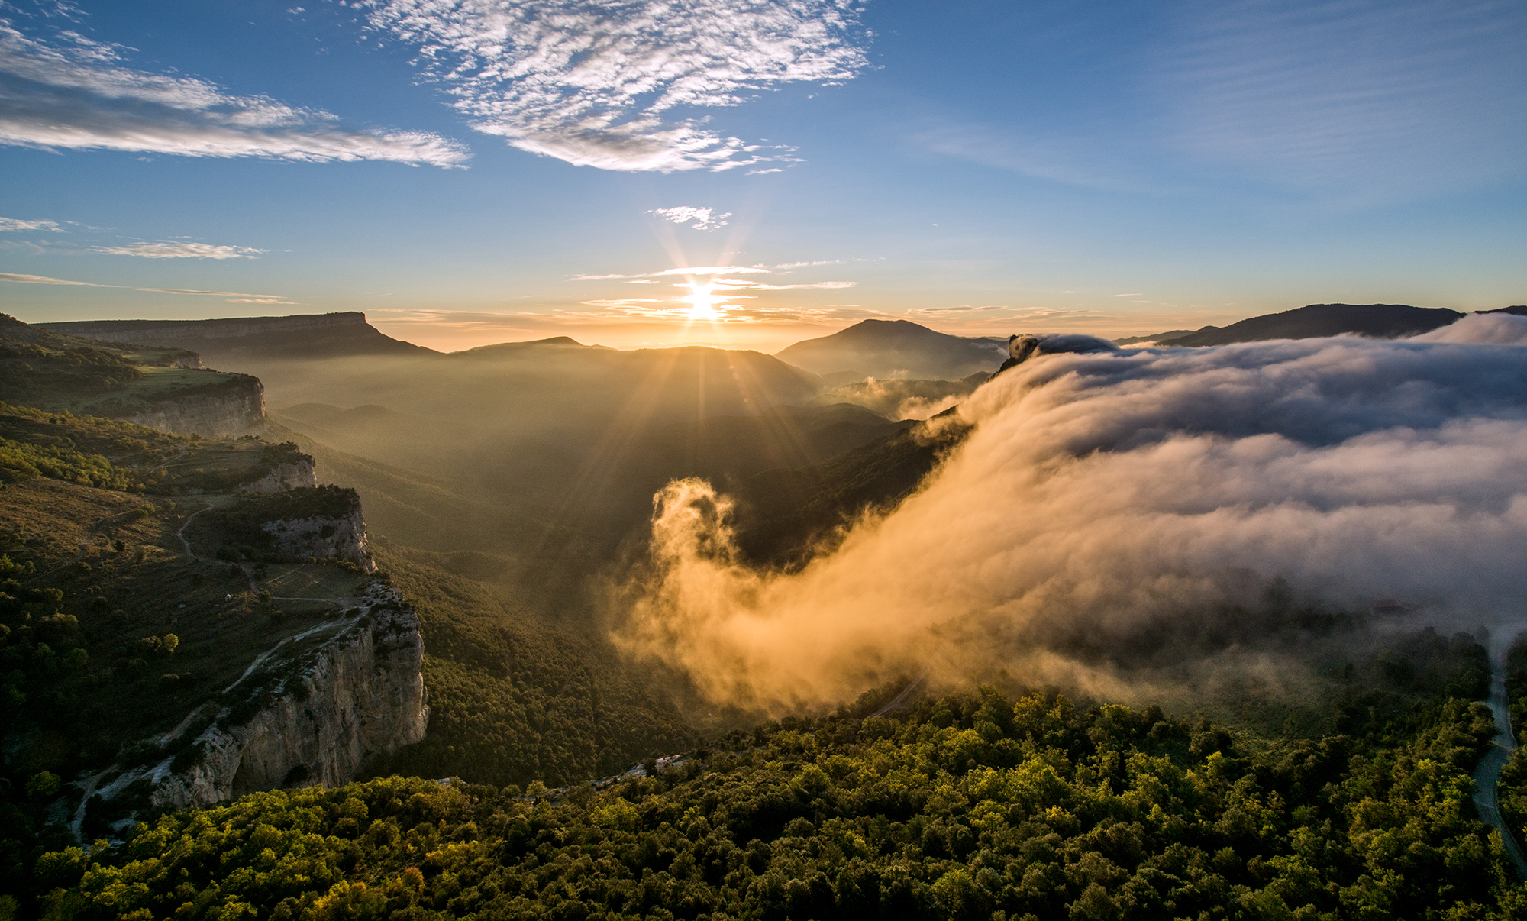
Best Tourism Villages
by UNWTO
联合国世界旅游组织最佳旅游乡村
Application Form 申请表
2023 Edition 2023年版

Best
Tourism Villages
by UNWTO
世界旅游组织
最佳旅游乡村

Application Form
申请表
2023 Edition
2023年版
March 2023
2023年3月

Application Form 申请表

Before you submit your application, we invite you to carefully read the following documents (available at http://www.unwto.org/tourism-villages/en/the-initiative/):
在提交申请之前，请认真阅读以下文件（可浏览http://www.unwto.org/tourism-villages/en/the- initiative/）：
- Terms and Conditions 条款与条件
- Guidelines for Application 申请指南
- Areas of Evaluation评审领域
- Candidacy Document 参选文件
- General Presentation Template 总体展示模板
IMPORTANT NOTES: 重要说明：
- All applications must be submitted online. 所有申请必须在线提交。
- All documents must be submitted in the format specified in the online application form and must not exceed the maximum length and/or size indicated. The title of each document should reflect the contents of the document.
所有文件须以在线申请表格的具体格式提交，不超过规定长度和/或大小。每份文件的标题应反映其内容。
- Make sure to have all mandatory documents ready for upload before submitting your application. Incomplete and/or late applications shall not be considered.
确保所有应交文件在提交申请前均已准备好上传。不完整和/或晚交的申请不被采纳。
- Once an application is submitted, no changes can be made. The submitted application will be considered as the final version.
申请提交后，不得更改。提交的申请将被视为最终版本。
- Deadline for applications is 23 June 2023 (23:59 CEST).
申请截止期限为2023年6月23日（欧洲中部时间23：59）。
- All fields marked with an asterisk (*) are mandatory. 所有标注(*)的表项为必填项。

Basic Information基本信息

- Name of the village*村庄名称 | Please make sure to write the exact name of the village. 请确保填写村庄的准确名称 | Open-ended Question  开放性问题
- Country*国家 |  | Drop-down Question下拉选项问题
- Geographical Coordinates of the village*:村庄地理坐标  - Latitude纬度  - Longitude经度 | Please use the decimal degrees format请使用十进制格式 | 2 open-ended questions两个开放性问题
- Population of the village (number of inhabitants) *村庄人口（居住人口数） | Considering that a maximum of 15.000 inhabitants is an eligibility pre-requisite, please indicate the number of inhabitants 考虑到居住人口最多为15000是申请的先决条件，请说明居住人口数。 | Open-ended Question 开放式问题
Submit/provide a supporting document of the population census for the village for the latest year available.* 提交/提供一个关于本村最近人口普查的支持性文件。 |  | File upload上传文件
Please provide the available data on the last 3 points on the population of the village (i.e. 3 last census). 请提供最近3点关于村庄人口的现有数据（即最近3次人口普查）。 |  | 3 Open-ended Questions 三个开放性问题
- Extent of the village’s territory (in square km)村庄面积（单位：平方公里） |  | Open-ended Question开放式问题
  - Contact information for representative in the village. 村庄代表联系信息
The contact provided will be the representative for all communications with UNWTO.
提供的联系人将作为与UNWTO沟通所有事务的代表。
- Title (Mr/Ms/Other)*称谓（先生/女士/其他） |  | Field Questions填空问题
    - Family Name*姓
    - First Name*名
    - Institution*机构
    - Position*职务
    - Street Address and Number*街道地址和门牌号
    - State/Province*国家/省份
    - Postal/Zip Code*邮编
    - Area Code + Telephone Number*国家区号+电话号码
    - E-mail Address*邮箱地址
  - Contact information for the responsible for the application at the UNWTO Member State
UNWTO成员国负责申报事务人员的联系信息
The responsible for the application of the village will be the representative of the UNWTO Member State. This person will be responsible for the communication and coordination of all issues related to the candidacy.
负责申报村庄事务的人员是UNWTO成员国代表，将负责与申报相关的所有沟通和协调事务。
- Title (Mr/Ms/Other)* 称谓（先生/女士/其他） |  | Field Questions 填空问题
    - Family Name*姓
    - First Name*名
    - Institution* 机构
    - Position*职务
    - Street Address and Number*街道地址和门牌号
    - State/Province国家/省份
    - Postal/Zip Code 邮编
    - Area Code + Telephone Number*国家区号+电话号码
    - E-mail Address*邮箱地址

- Key Tourism Data主要旅游数据

Visitors游客
If available, we kindly ask you to provide the following for the last 4 years or the ones available in any of the years from that period. 如可能，我们希望请您提供过去4年或这期间任意年份的如下信息。
Data数据 | 2019 | 2020 | 2021 | 2022
Total number of overnight visitors (total tourists)*过夜游客总数（全部游客）
Total number of international overnight visitors (international tourists)过夜国际游客总数（国际游客）
Total number of domestic overnight visitors (domestic tourists)过夜国内游客总数（国内游客）
Total number of same-day visitors (excursionists)*当日游客总数（游览者）

If available, we kindly ask you to provide the following for 2022 or the last year available. 如可能，我们希望请您提供2022年或上一年的如下信息。
Average visitor expenditure (per person) in local currency: 以当地货币计算的游客平均支出（每人）：

- Please specify the currency 请明确货币 Drop down 下拉选择
- Please specify the amount 请明确数额 Open field question (numbers only)开放式问题（仅填数字）
- Please specify the reference year 请明确年份 Open field question (numbers only) 开放式问题（仅填数字）

Main origin of visitors: 游客主要来源：

Please use boxes below to select top 3 main visitor's countries of origin. If domestic visitors are part of the main origins, please include.
请使用下方方框选择3个主要的游客来源国家。如国内游客是主要来源地的一部分，请包括在内。
- Select country. 选择国家 Drop down question 下拉选项问题
- Select country. 选择国家 Drop down question 下拉选项问题
- Select country. 选择国家 Drop down question 下拉选项问题

Tourism products and tourism related businesses 旅游产品和旅游相关产业

Data数据 | Number数字 | Year of reference参考年份
Total number of tourism businesses in the village本村旅游企业总数
Total number of rooms available in the village (accommodation capacity)* 本村可用客房总数（住宿接待能力）

Main tourism products/experiences: 主要旅游产品/经验：

Please, use the box below to list the main types of tourism products offered by the village:
请使用下方方框列出本村提供的主要旅游产品类型：
- Open text. 开放式文本 Open field question 开放式问题

Employment 就业

Data 数据 | Number 数字 | Year of reference 参考年份
Total number of employed people in the village 本村就业人口总数
Total number of employed people in tourism related jobs in the village 本村旅游业相关工作的就业人口总数
Total number of employed women in tourism related jobs in the village本村旅游业相关工作的女性就业人口总数

- Motivation and Areas of Evaluation 动机和评审领域

- Please upload a short video either in English or Spanish telling us why the village should become a Best Tourism Village by UNWTO. *  请上传一份英语或西班牙语的短视频，陈述本村成为“UNWTO最佳旅游乡村”的理由。  Format and limit specified: mp4 format, 2min max., 30MB max.  文件格式和限制规定：mp4格式，不超过2分钟，不超过30MB。 | File upload field 上传文件区域
- Please upload a general presentation following the structure provided in the template “General Presentation”. *  请参照“总体展示”模板，上传一份总体展示文件。  Format and limit specified: PDF format, 12 slides max, 20MB max.  文件格式和限制规定：PDF格式，幻灯片不超过12张，不超过20MB。 | File upload field上传文件区域
- Please upload the document “Candidacy Document” completed. *  请上传填写完毕的“参选文件”。  Format and limit specified: PDF format, limit specified in the number of words allowed per question, 20MB max.  文件格式和限制规定：PDF格式，每个问题在规定字数内回答，不超过20MB。 | File upload field 上传文件区域

Supporting Visual Files 支持性视觉文件

- Please upload relevant supporting visual files that are relevant to showcase the village resources and initiatives.*  请上传相关的支持性视觉文件，展示村庄的资源和活动。  Format and limit specified: 文件格式和限制规定：  Images: jpg. Up to 10 images. 20MB per file max.图片：jpg格式，不超过10张，每个文件不超过20MB。  Videos: mp4. Up to 3 videos. 30MB per file max.视频：mp4格式，不超过3个视频，每个文件不超过30MB。 | File upload field上传文件区域
- Please provide up to three YouTube links (or to other similar video sharing platforms (i.e.: vimeo, Tencent, iQiyi, etc.) of promotional videos of the village (if any).  请提供不超过3个村庄宣传片的油管（YouTube）链接（或其他类似视频分享平台，如：Vimeo、腾讯、爱奇艺，等等）（如有）。 | 3 link fields 三个链接填空

Compliance Framework 汇总框架

How did you learn about the Best Tourism Villages by UNWTO initiative? *你如何知悉“UNWTO最佳旅游乡村”项目？ | - UNWTO website UNWTO网站  - Social Media 社交媒体  - Direct Communication from UNWTO 与UNWTO直接联系  - Press 新闻  - Event 活动  - Recommendation from colleague or partner 同事或伙伴推荐  - Other 其他 | Multiple Choice Question 多选问题

- I am/We are aware and accept the Statutes of UNWTO and the Global Code of Ethics for Tourism *  我/我们了解并接受UNWTO章程和全球旅游道德守则。 | ☐  YES 是
2. I am/We are aware and accept to comply with the Terms and Conditions of ‘Best Tourism Villages by UNWTO’ initiative. Accordingly, I/we recognize that UNWTO reserves the right to suspend or exclude a village from ‘Best Tourism Villages by UNWTO’ Network at any time in case of breach of these Terms and Conditions, for not meeting the requirements for joining the initiative for any other reason duly justified.*  我/我们了解并接受“UNWTO最佳旅游乡村”项目的条款和条件。因此，我/我们确认，只要有违反条款和条件、因其他原因不符合加入本项目的要求，UNWTO保留在任何时候暂停或除去一个村庄“UNWTO最佳旅游乡村”网络的权利。 | ☐  YES 是
3. I/We understand and accept that the village, once officially a member of ‘Best Tourism Villages by UNWTO’ Network may mention its membership as such. Only villages recognised as Best Tourism Villages by UNWTO can use the initiative’s logo according to the Terms and Conditions and to the Guidelines for the use of the logo. Any use of UNWTO’s signs (name, emblem, flag or acronym) shall be subject to prior written authorization by UNWTO and in full compliance with the terms and conditions in accordance with UNWTO Terms of Use.*  我/我们理解并接受，本村庄，一旦正式成为“UNWTO最佳旅游乡村”网络成员，可提及此成员身份。只有被确认为“UNWTO最佳旅游乡村”的村庄才可根据《条款和条件》及标识使用指南使用此项目的标识。任何UNWTO标识（名称、徽标、旗帜或首字母缩写）的使用，都应事先获取UNWTO书面授权，并根据《UNWOT使用条款》完全遵守条款和条件。 | ☐  YES 是
4. By becoming a Member of ‘Best Tourism Villages by UNWTO’ Network, the village accepts to comply with the terms and conditions established by the UNWTO, in particular on the use of UNWTO signs and the prohibition to be involved in any activity that could be opposed to the objectives or principles of the UNWTO or the UN or that could adversely reflect upon the UNWTO.*  成为“UNWTO最佳旅游乡村”网络成员，本村接受遵守UNWTO设立的条款和条件，特别是在使用UNWTO标识以及禁止参与任何可能与UNWTO或联合国目标或原则相悖，或对UNWTO可能产生负面影响的活动。 | ☐  YES 是
UNDERTAKING 承诺
I, hereby, declare that all the information provided above is true and correct to the best of my knowledge and that I have read, understood and accepted the Terms and Conditions and agree to all of the terms therein. Should I fail to adhere to the conditions set out by said Terms and Conditions, I understand that the UNWTO reserves the right to dismiss my application or remove the recognition to the village.*  我，在此，宣布上述所有提供的信息据我所知皆为真实、无误，我已阅读、理解和接受《条款和条件》，并同意此中的所有条款。如不能遵守所述《条款和条件》中的条件，我理解UNWTO保留撤除我的申请的权利。 | ☐  YES 是
DATA PROTECTION 数据保护
1. By submitting their application, participants acknowledge that referenced projects and visual materials are their own originals and/or they own the necessary right to ownership or property rights thereover. Participants shall duly credit third party copyrights and license to use them when applicable or if requested by the Secretariat at any time. Participants agree to hold harmless UNWTO from any and all losses, claims, damages, expenses or liabilities which could arise in relation to intellectual property rights or personal data of third parties in relation to the applications submitted and visual materials uploaded in the application. UNWTO shall not claim any property on the initiatives submitted or any other industrial or intellectual property contained in their application. Participants do not cede UNWTO industrial or intellectual property rights arising as a result of their applications.*  通过提交申请，参与者承认所引用的项目属于其原创，并/或拥有必要的所有权或著作权。参与者应适时或应秘书处任何时候要求时，适当记入第三方版权和使用许可。参与者同意使UNWTO 免受任何与所有可能因提交申请而产生的与知识产权或第三方个人数据相关的损失、索赔、损坏、开支或负债。UNWTO 不应对提交项目或申请中包含的其他工业或知识产权索取所有权。参与者不向UNWTO 让与因其申请而产生的工业或知识产权。 | ☐  YES 是
2. By submitting their application, participants expressly grant their consent to the use of the name or their village and initiatives in connection with the ‘Best Tourism Villages by UNWTO’ initiative and the recording and maintenance of related files. Participants may exercise their rights to access, modify, cancel and oppose the processing of their personal details by sending an email to besttourismvillages@unwto.org indicating which right they wish to exercise and attaching a copy of their passport, national ID card or equivalent documentation.*  通过提交申请，参与者明确同意使用其村庄名称和与“UNWTO最佳旅游乡村”项目、相关文件的记录和维护有关的活动。参与者可通过发送邮件至besttourismvillage@unwto.org 行使其获取、修改、取消及反对对其个人详细信息的处理等权利，指出希望行使的权利并附上其护照、国家身份证件或同等文件的副本。 | ☐  YES 是
☐ I agree* 我同意

Name** 姓名
Organization * 机构
Position* 职务
Country* 国家
Date* 日期

**The person submitting the application is the responsible for the application at the UNWTO Member State (same person indicated in field 1.7.).
提交申请的人员负责UNWTO成员国的申请事务（与表项1.7所填人员一致）。
March 2023
2023年3月

With the vision of making tourism a positive force for transformation, rural development and community wellbeing, the Best Tourism Villages by UNWTO initiative seeks to advance the role of tourism in valuing and safeguarding rural villages along with their associated landscapes, knowledge systems, biological and cultural diversity, local values and activities.

The World Tourism Organization (UNWTO), a United Nations specialized agency, is the leading international organization with the decisive and central role in promoting the development of responsible, sustainable and universally accessible tourism. It serves as a global forum for tourism policy issues and a practical source of tourism knowhow. Its membership includes 160 countries, 6 territories, 2 permanent observers and over 500 Affiliate Members.

World Tourism Organization (2022) UNWTO Basic Documents, Volume I ‐ Statutes, Rules of Procedure, Agreements, seventh edition, UNWTO, Madrid. https://doi.org/10.18111/9789284423781
https://webunwto.s3.eu-west-1.amazonaws.com/imported_images/37802/gcetbrochureglobalcodeen.pdf
A/RES/601(XIX) available at https://www.e-unwto.org/doi/pdf/10.18111/unwtogad.2011.1.q143011gl1856q48

